Table 4. SR, KA and M_{RR} values for multiple experiments
 | S.no | pressure (MPa) | stand of distance (mm) | traverse speed (mm/min) | Mass flow rate (kg/min) | Surface roughness (µm) | Material removal rate (mm³/sec) | kerf
 | 1 | 220 | 2 | 80 | 0.4 | 4.75 | 119.98 | 2.08
 | 2 | 260 | 1 | 64 | 0.55 | 3.09 | 126.36 | 1.44
 | 3 | 220 | 2 | 80 | 0.45 | 4.46 | 122.4 | 1.98
 | 4 | 140 | 3 | 96 | 0.55 | 5.02 | 111.57 | 2.25
 | 5 | 300 | 1 | 96 | 0.35 | 3.84 | 126.63 | 1.75
 | 6 | 140 | 1 | 64 | 0.35 | 5.04 | 97.63 | 2.25
 | 7 | 220 | 2 | 72 | 0.45 | 4.38 | 121.6 | 1.95
 | 8 | 140 | 3 | 64 | 0.55 | 4.61 | 109.81 | 2.09
 | 9 | 280 | 2 | 80 | 0.45 | 4.14 | 137.08 | 1.83
 | 10 | 300 | 1 | 64 | 0.35 | 3.5 | 117.28 | 1.59
 | 11 | 300 | 3 | 96 | 0.35 | 3.97 | 143.3 | 1.86
 | 12 | 220 | 2 | 88 | 0.45 | 4.63 | 125.7 | 2.04
 | 13 | 140 | 3 | 96 | 0.35 | 5.56 | 106.95 | 2.57
 | 14 | 300 | 3 | 96 | 0.55 | 3.62 | 148.41 | 1.64
 | 15 | 140 | 1 | 64 | 0.55 | 4.08 | 102.02 | 1.86
 | 16 | 180 | 2 | 80 | 0.45 | 4.75 | 115.2 | 2.15
 | 17 | 220 | 2 | 80 | 0.45 | 4.46 | 122.4 | 1.98
 | 18 | 220 | 1.5 | 80 | 0.45 | 4.41 | 119.69 | 1.96
 | 19 | 300 | 3 | 64 | 0.55 | 3.42 | 145.92 | 1.52
 | 20 | 220 | 2 | 80 | 0.5 | 4.27 | 131.74 | 1.93
 | 21 | 220 | 2.5 | 80 | 0.45 | 4.67 | 132.71 | 2.05
 | 22 | 140 | 1 | 96 | 0.35 | 5.36 | 99.7 | 2.43
 | 23 | 300 | 1 | 96 | 0.55 | 3.29 | 140.98 | 1.48
 | 24 | 220 | 2 | 80 | 0.45 | 4.46 | 122.4 | 1.98
 | 25 | 140 | 1 | 96 | 0.55 | 4.53 | 104.26 | 2.08
 | 26 | 140 | 3 | 64 | 0.35 | 5.23 | 103.66 | 2.34
 | 27 | 300 | 3 | 64 | 0.35 | 3.80 | 139.85 | 1.73

Table 5: Hyperparametrs for optimized models.
Output | Ridge Hyper  parameter | Ridge R² | RF Hyperparameter | RF R² | SVR  Hyperparameter | SVR  R² | Elasticnet Hyper  parameter | EN R²
Surface Roughness | {'alpha': 1} | 0.925 | {'n_estimators': 100, 'max_depth': 10} | 0.9706 | {'C': 10, 'kernel': 'rbf', 'gamma': 'scale'} | 0.9811 | {'alpha': 0.1, 'l1_ratio': 0.5} | 0.8871
Material Removal Rate | {'alpha': 1} | 0.9400 | {'n_estimators': 100, 'max_depth': 10} | 0.9730 | {'C': 10, 'kernel': 'rbf', 'gamma': 'scale'} | 0.8876 | {'alpha': 0.1, 'l1_ratio': 0.5} | 0.9386
Kerf Angle | {'alpha': 1} | 0.9672 | {'n_estimators': 100, 'max_depth': 10} | 0.9758 | {'C': 10, 'kernel': 'rbf', 'gamma': 'scale'} | 0.9133 | {'alpha': 0.1, 'l1_ratio': 0.5} | 0.8126

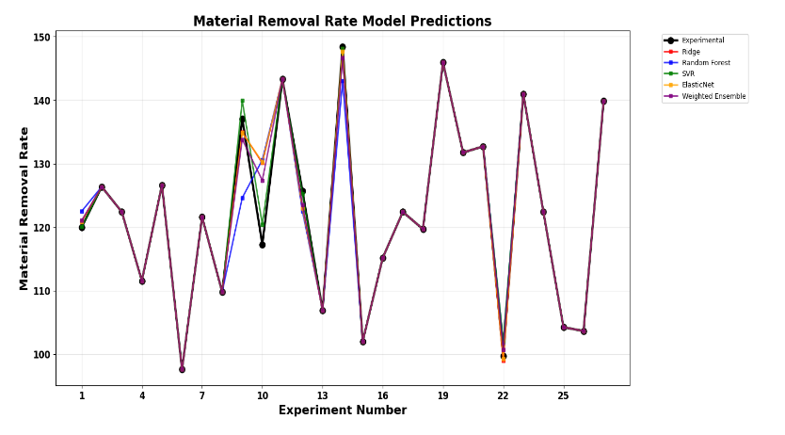
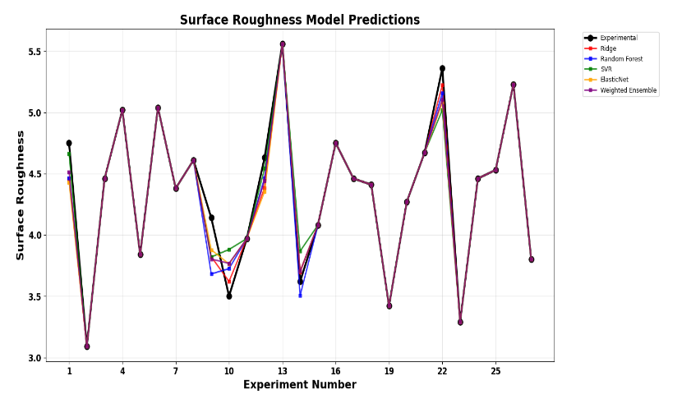

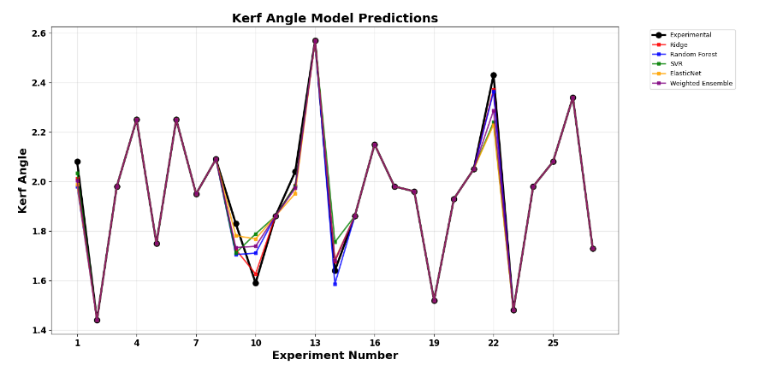

Fig. 7. Validation of each model with experimental value

Table 6: Ensemble Model performance.
Ensemble Model Performance Summary
Target | RMSE | MAE | R²
Surface Roughness | 0.1194 | 0.1011 | 0.9633
Material Removal Rate | 2.9201 | 2.3389 | 0.9589
Kerf Angle | 0.0678 | 0.0567 | 0.9401

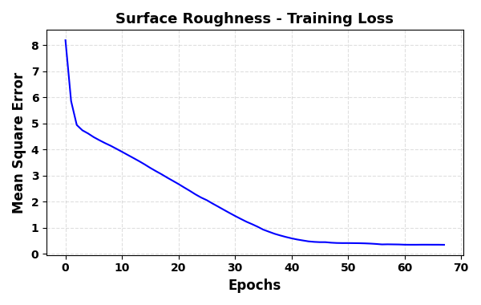
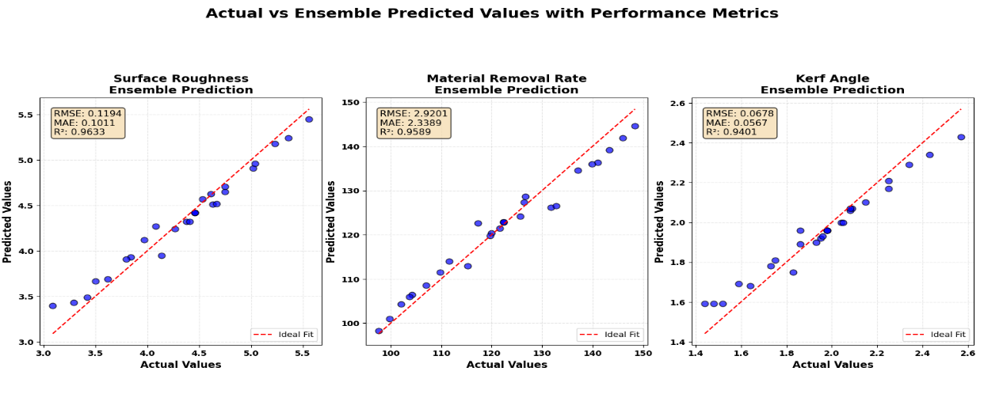
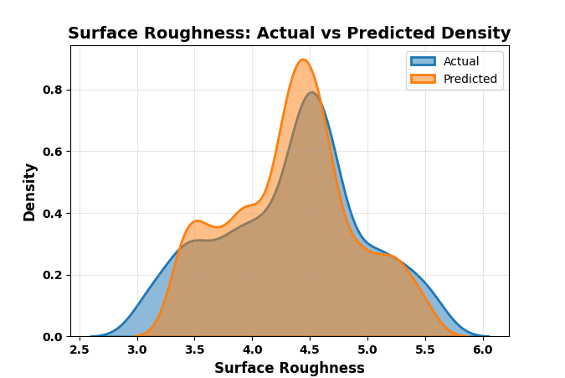
SURFACE ROUGHNESS

- (b) (c)
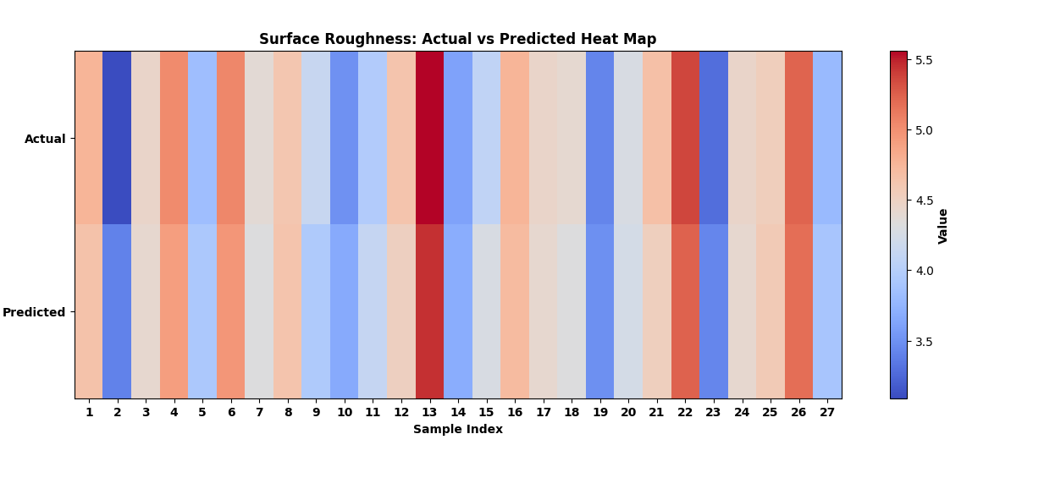

Fig. 8. Ensemble Surface Roughness Model Performance (a) Training and Validation Curve (b) Actual vs Predicted value (c) Density curve (d) Heat map.

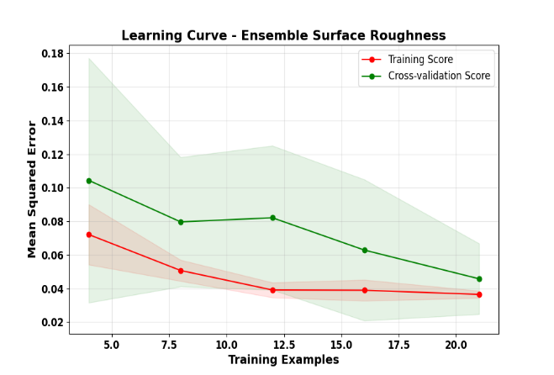
Fig. 11. Learning curve for Cross-validation Surface Roughness

Material Removal Rate
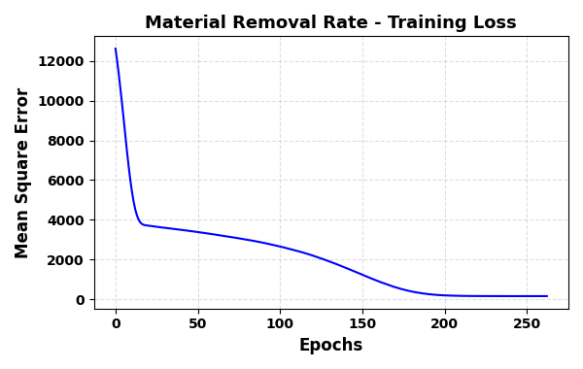

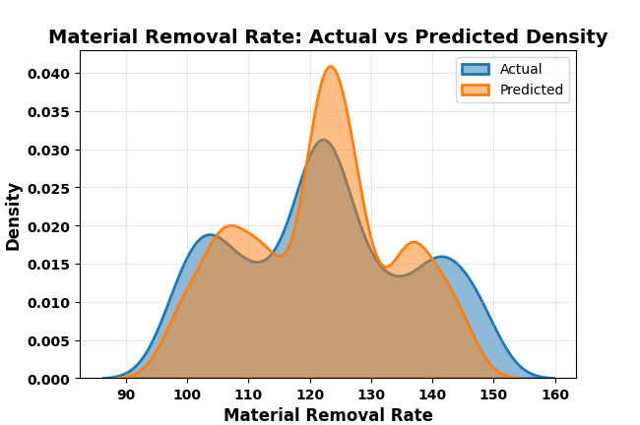

- (b) (c)
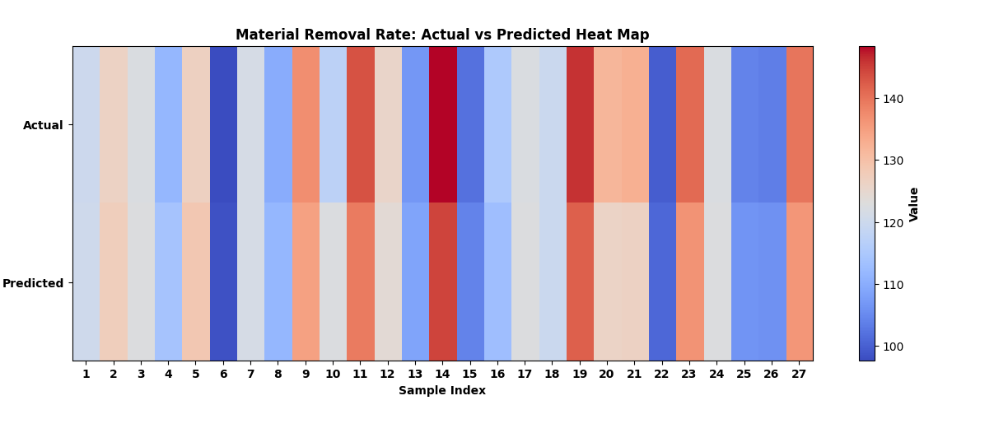
Fig. 8. Ensemble Material Removal Rate Model Performance (a) Training and Validation Curve (b) Actual vs Predicted value (c) Density curve (d) Heat map.

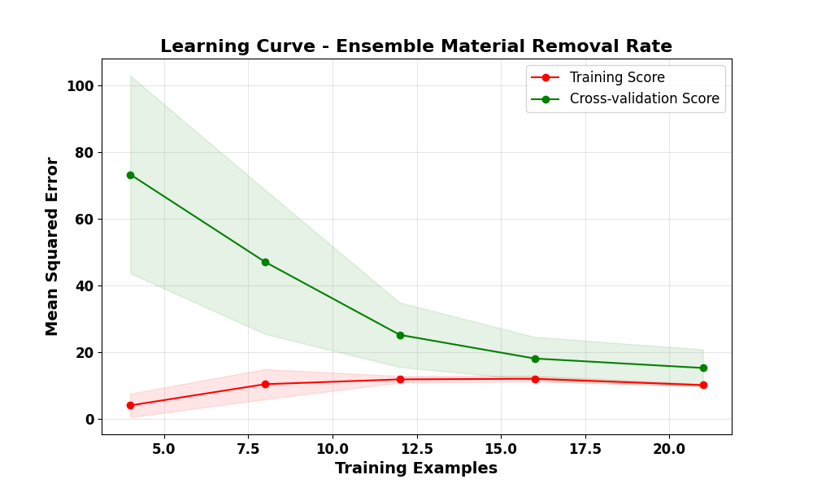
(d)

Fig. 11. Learning curve for Cross-validation Material Removal Rate


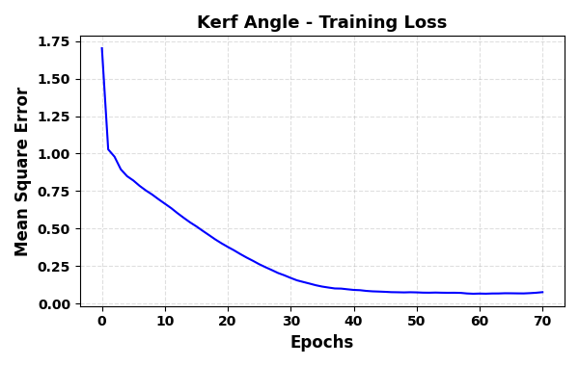
KERF ANGLE
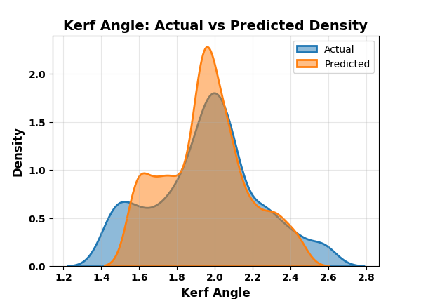

- (b) (c)
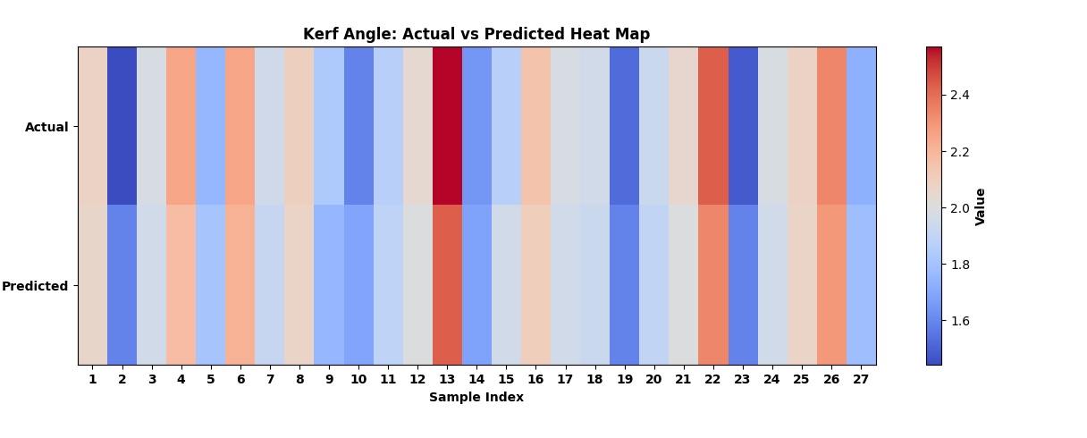
Fig. 8. Ensemble Kerf Angle Performance (a) Training and Validation Curve (b) Actual vs Predicted value (c) Density curve (d) Heat map.

(d)

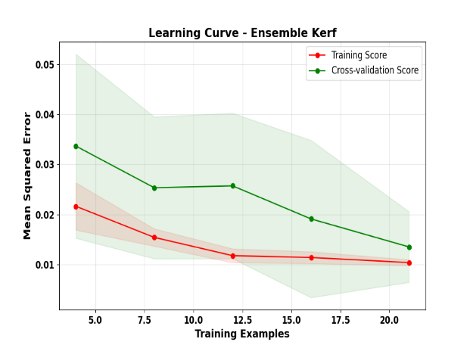

Fig. 11. Learning curve for Cross-validation Kerf Angle

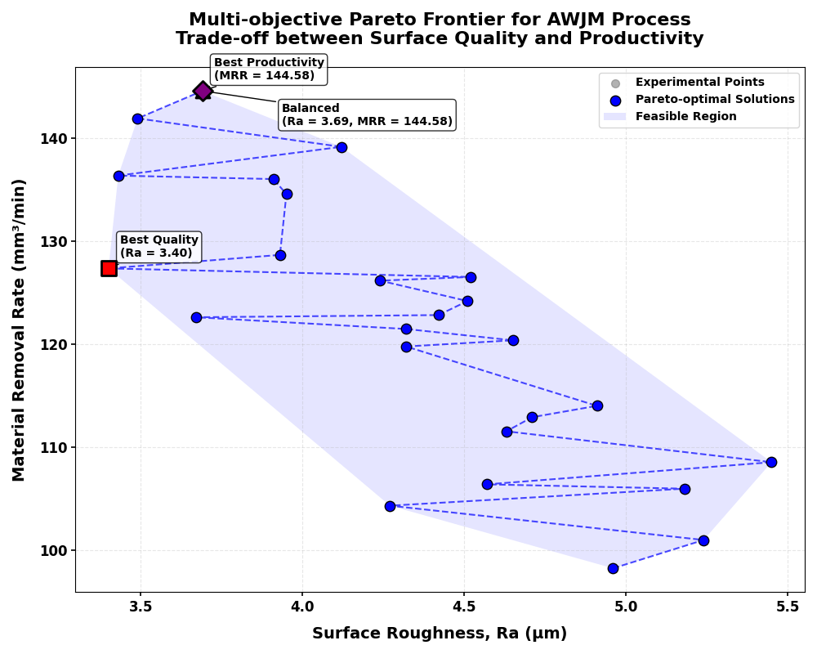

Table 3: Optimal Process Parameter Settings for Different Objectives
Parameter | Min Ra | Max MRR | Balanced
Pressure (MPa) | 260.00 | 300.00 | 300.00
Standoff Distance (mm) | 1.00 | 3.00 | 3.00
Traverse Speed (mm/min) | 64.00 | 96.00 | 96.00
Mass Flow Rate (kg/min) | 0.55 | 0.55 | 0.55
Expected Ra (μm) | 3.40 | 3.69 | 3.69
Expected MRR (mm³/min) | 127.35 | 144.58 | 144.58
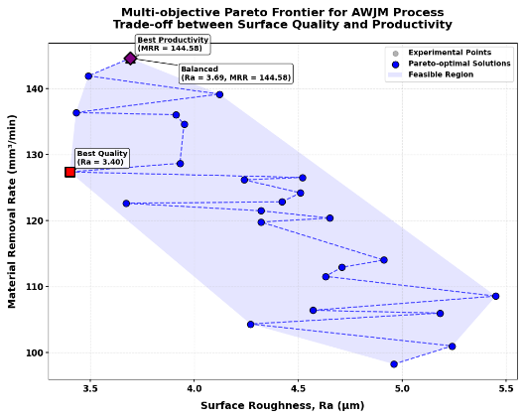
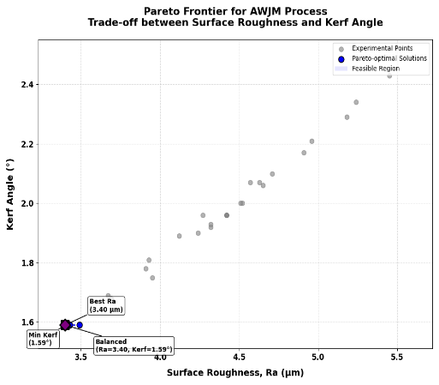
Table 3: Optimal Process Parameter Settings for Different Objectives
Parameter | Min Ra | Min Kerf | Balanced
Pressure (MPa) | 260.00 | 260.00 | 260.00
Standoff Distance (mm) | 1.00 | 1.00 | 1.00
Traverse Speed (mm/min) | 64.00 | 64.00 | 64.00
Mass Flow Rate (kg/min) | 0.55 | 0.55 | 0.55
Expected Ra (μm) | 3.40 | 3.40 | 3.40
Expected MRR (mm³/min) | 1.59 | 1.59 | 1.59

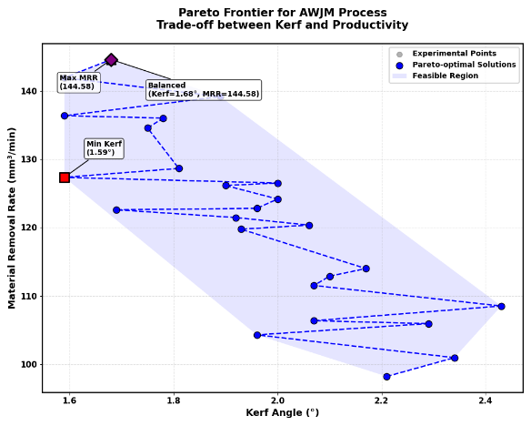
Table 3: Optimal Process Parameter Settings for Different Objectives
Parameter | Min Kerf | Max MRR | Balanced
Pressure (MPa) | 260.00 | 300.00 | 300.00
Standoff Distance (mm) | 1.00 | 3.00 | 3.00
Traverse Speed (mm/min) | 64.00 | 96.00 | 96.00
Mass Flow Rate (kg/min) | 0.55 | 0.55 | 0.55
Expected Kerf (°) | 1.59 | 1.68 | 1.68
Expected MRR (mm³/min) | 127.35 | 144.58 | 144.58

Table 3: Optimal Process Parameter Settings for Different Objectives

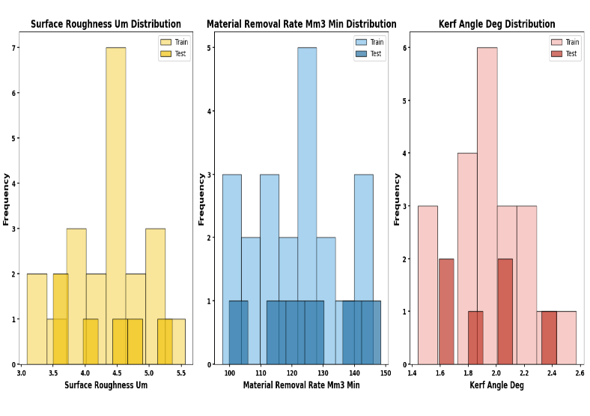
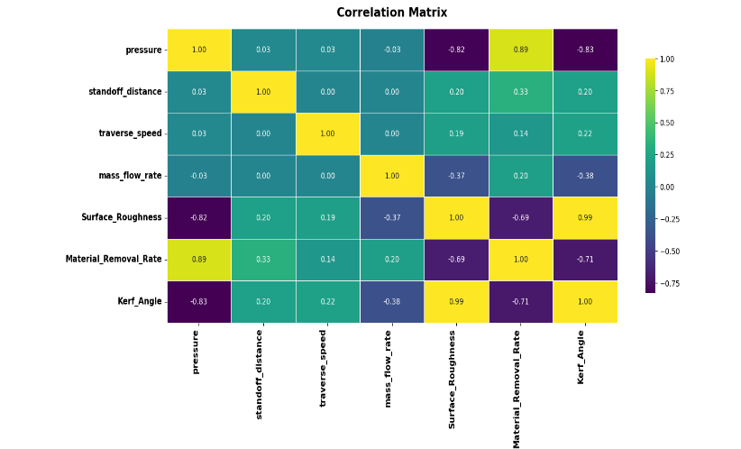
Distribution:

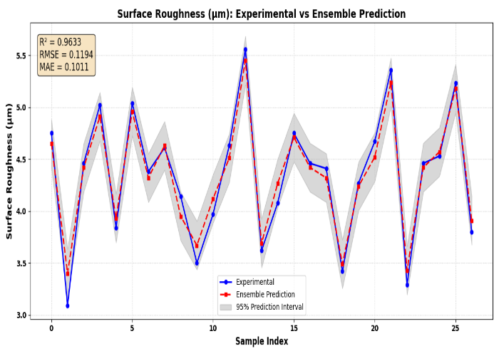
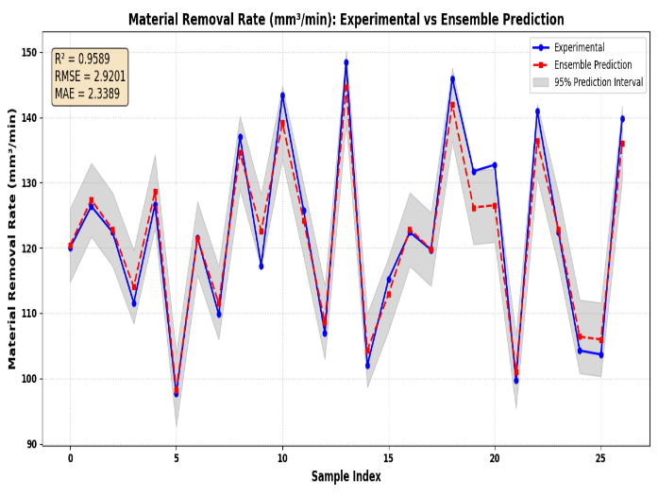
BOOSTRAP

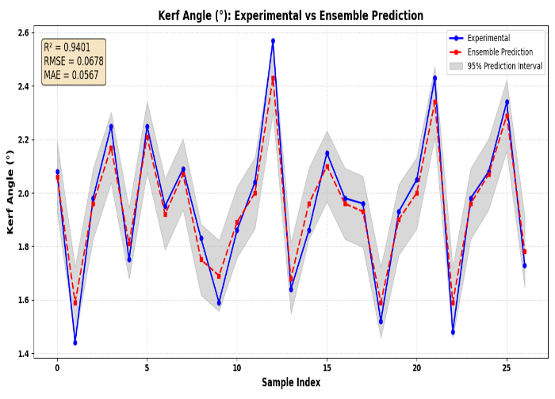
HYBRID Ensemble
